**Bulk Updating Test Cases**

Let’s say Pavan has quit his job and you hired EMRE instead of him

In this case, you need to find all the tests that are assigned to Pavan, remove Pavan and assign emre instead on by one.

Or all the test that are in design status has some problems and you need to put them in repair status

So instead of doing these changes one by one we use “REPLACE” function

You have to be in Test Grid View in order to use Replace

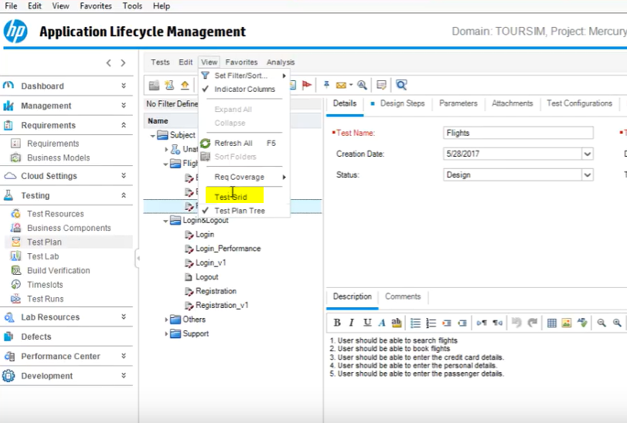

Then go to Edit and click on Replace

